Parga Beach Resort — Blocked Room Options
room & floorplan summary

Information:
- All rates are nightly, there is a 5-night minimum.
- All rates are inclusive of taxes and fees.
- Breakfast is included in all listed rates.

Quick Comparison
Room option | Size | Sleeping arrangement | Nightly rate
Eden Suite | 33 sq m / 355 sq ft | 1 bedroom with pull-out sofa | 2 persons:€400/night  3 persons:€450/night  4 persons:€470/night
Eden Suite with Attic/Loft | 43 sq m / 463 sq ft | 1 bedroom with pull-out sofa + 2nd bedroom with full bed | 2 persons:€430/night  3 persons:€480/night  4 persons:€520/night
Aura Suite | 40 sq m / 430 sq ft | 1 bedroom + living room with pull-out sofa | 2 persons:€440/night  3 persons:€490/night  4 persons:€530/night
Aura Suite with Private Pool | 40 sq m / 430 sq ft | 1 bedroom + living room with pull-out sofa | 2 persons:€520/night  3 persons:€570/night  4 persons:€600/night
Penthouse Bliss Suite with Plunge Pool | 57 sq m / 484 sq ft | 2 bedroom areas + 2 baths; the second bedroom area has two twin beds | Up to 4 persons: €650/night  Up to 5 persons: €700/night
Beachfront Panorama Suite with Jet Tub | 45 sq m / 485 sq ft | 1 bedroom space + living room with pull-out sofa | Up to 4 persons: €900/night
Beachfront Bliss Suite with Private Pool | 50 sq m / 538 sq ft | 1 bedroom space + living room with pull-out sofa | Up to 4 persons: €900/night
Beachfront Maison Suite with Private Pool | 70 sq m / 753 sq ft | 2 bedroom spaces + 2 baths + living room with pull-out sofa | Up to 4 persons: €1,250/night  Up to 5 persons: €1,300/night

1. Eden Suite
Size | 33 sq m / 355 sq ft
Rooms available | 13 rooms
SLEEPING ARRANGEMENT | 1 bedroom with pull-out sofa
Layout / setup | One-bedroom suite with pull-out sofa.
Nightly rate | 2 persons: €400/night  3 persons: €450/night  4 persons: €470/night
Notes | The trip sheet identifies 13 rooms. Breakfast is included; rates are nightly and inclusive of taxes and fees.
Complete floorplan
https://www.pargabeachresort.gr/rooms/eden-suite/https://www.pargabeachresort.gr/rooms/eden-suite/
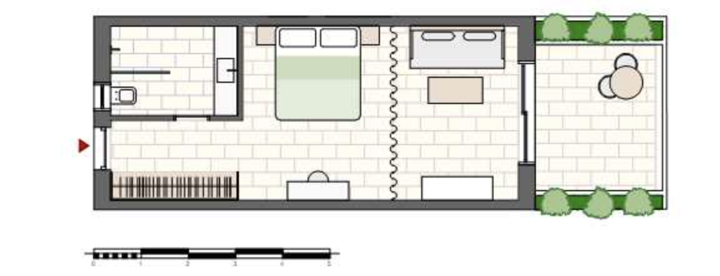

2. Eden Suite with Attic/Loft
Size | 43 sq m / 463 sq ft
Rooms available | 1 room
SLEEPING ARRANGEMENT | 1 bedroom with pull-out sofa + 2nd bedroom with full bed
Layout / setup | Two-level / attic layout. The second sleeping area is on the upper level.
Nightly rate | 2 persons: €430/night  3 persons: €480/night  4 persons: €520/night
Notes | The trip sheet identifies 1 room. Breakfast is included; rates are nightly and inclusive of taxes and fees.
Complete floorplan
https://www.pargabeachresort.gr/rooms/eden-suite-with-attic/
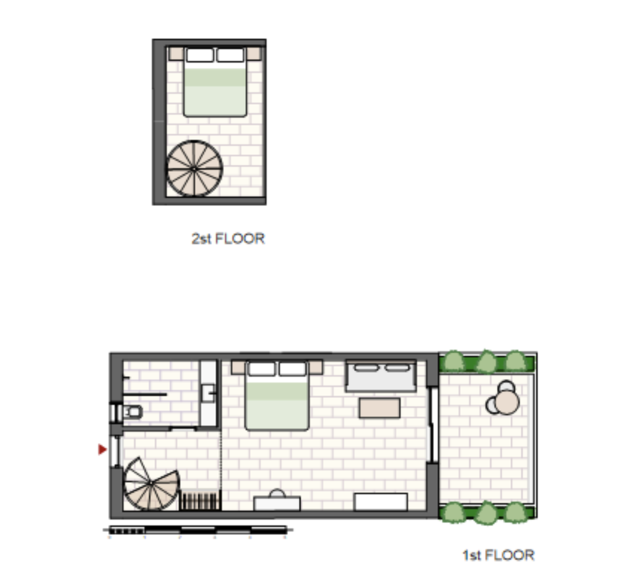

3. Aura Suite
Size | 40 sq m / 430 sq ft
Rooms available | 1 room
SLEEPING ARRANGEMENT | 1 bedroom + living room with pull-out sofa
Layout / setup | One-level suite with separate bedroom and living room.
Nightly rate | 2 persons: €440/night  3 persons: €490/night  4 persons: €530/night
Notes | The trip sheet identifies 1 room. Breakfast is included; rates are nightly and inclusive of taxes and fees.
Complete floorplan
https://www.pargabeachresort.gr/rooms/aura-suite/https://www.pargabeachresort.gr/rooms/aura-suite/
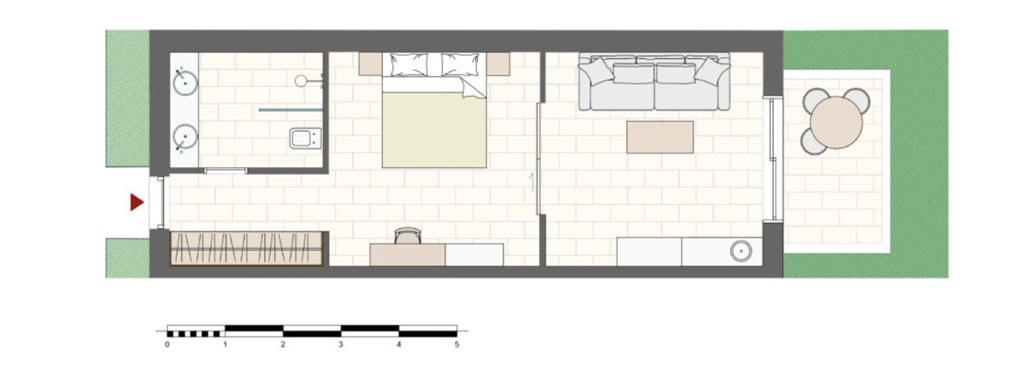

4. Aura Suite with Private Pool
Size | 40 sq m / 430 sq ft
Rooms available | 7 rooms
SLEEPING ARRANGEMENT | 1 bedroom + living room with pull-out sofa
Layout / setup | One-level suite with private pool.
Nightly rate | 2 persons: €520/night  3 persons: €570/night  4 persons: €600/night
Notes | The trip sheet identifies 7 rooms. Breakfast is included; rates are nightly and inclusive of taxes and fees.
Complete floorplan
https://www.pargabeachresort.gr/rooms/aura-suite-with-private-pool/https://www.pargabeachresort.gr/rooms/aura-suite-with-private-pool/
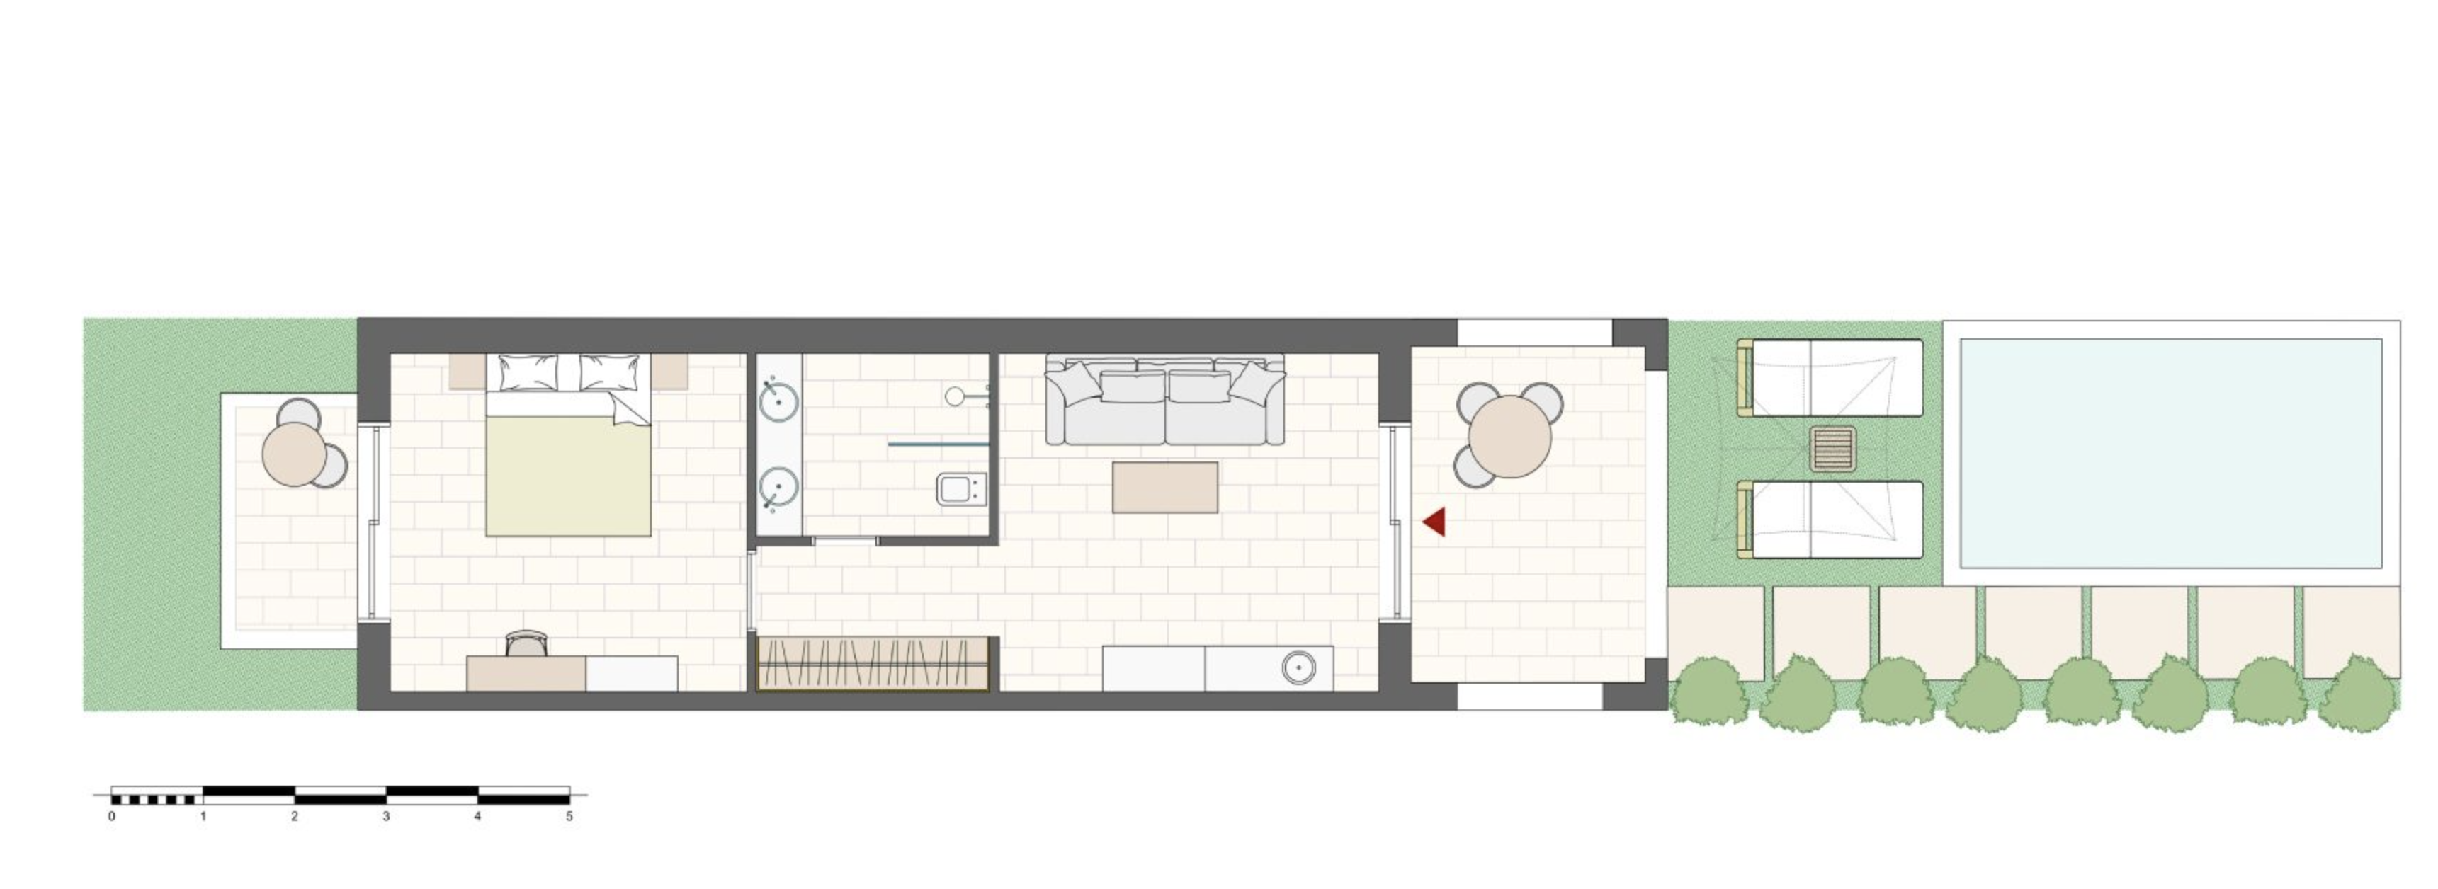

5. Penthouse Bliss Suite with Plunge Pool
Size | 57 sq m / 484 sq ft
Rooms available | 2 rooms
SLEEPING ARRANGEMENT | 2 bedroom areas + 2 baths; the second bedroom area has two twin beds
Layout / setup | Two-floor suite. The second bedroom area with two twin beds is on the upper/second-floor sleeping level.
Nightly rate | Up to 4 persons: €650/night  Up to 5 persons: €700/night
Notes | This corrects the earlier version: the second bedroom area is a genuine sleeping area with two twin beds. The supplied trip sheet calls the outdoor feature an outdoor outdoor hot tub.
Complete floorplan
https://www.pargabeachresort.gr/rooms/penthouse-bliss-suite-with-plunge-pool/
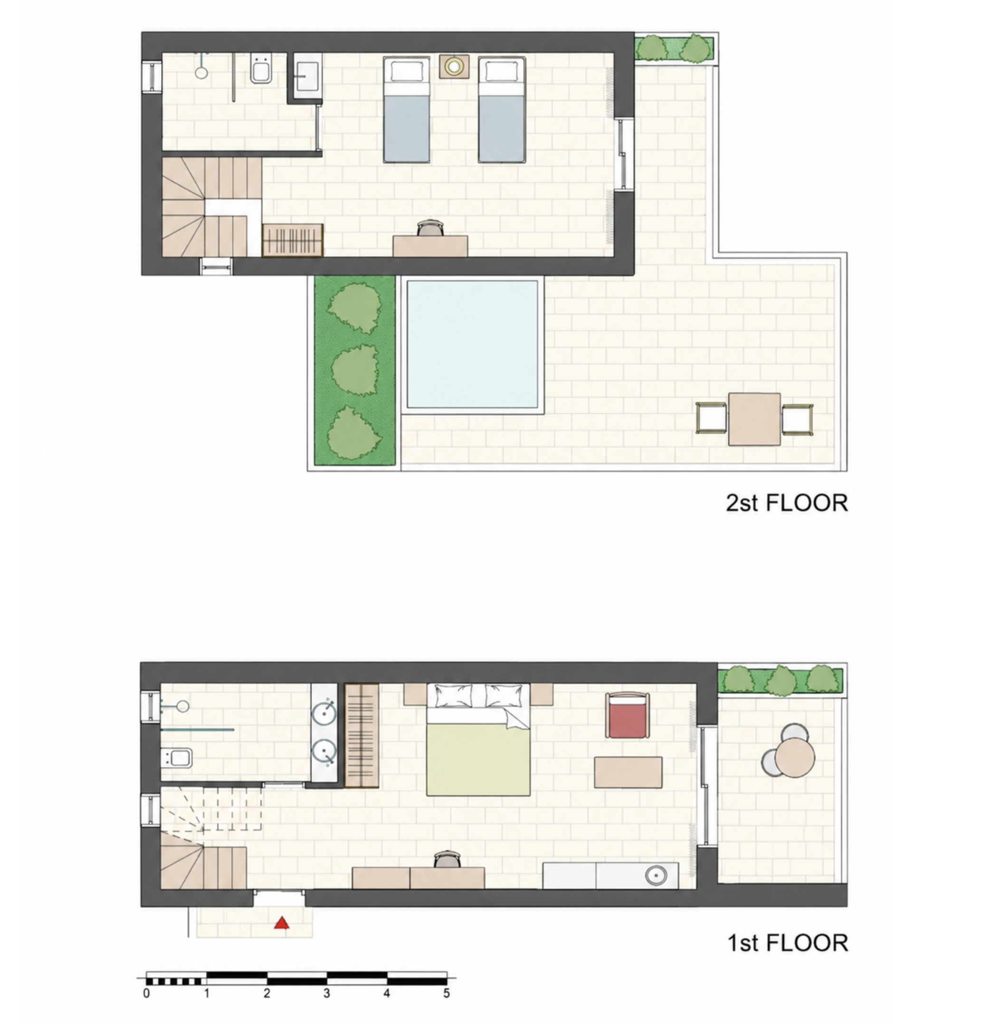

6. Beachfront Panorama Suite with Jet Tub
Size | 45 sq m / 485 sq ft
Rooms available | 4 rooms
SLEEPING ARRANGEMENT | 1 bedroom space + living room with pull-out sofa
Layout / setup | Beachfront suite with separate bedroom space and living room.
Nightly rate | Up to 4 persons: €900/night
Notes | The handwritten trip note specifies 2 adults + 2 children for the 4-person option. Breakfast is included; rates are nightly and inclusive of taxes and fees.
Complete floorplan
https://www.pargabeachresort.gr/rooms/beachfront-panorama-suite-with-jet-tub/
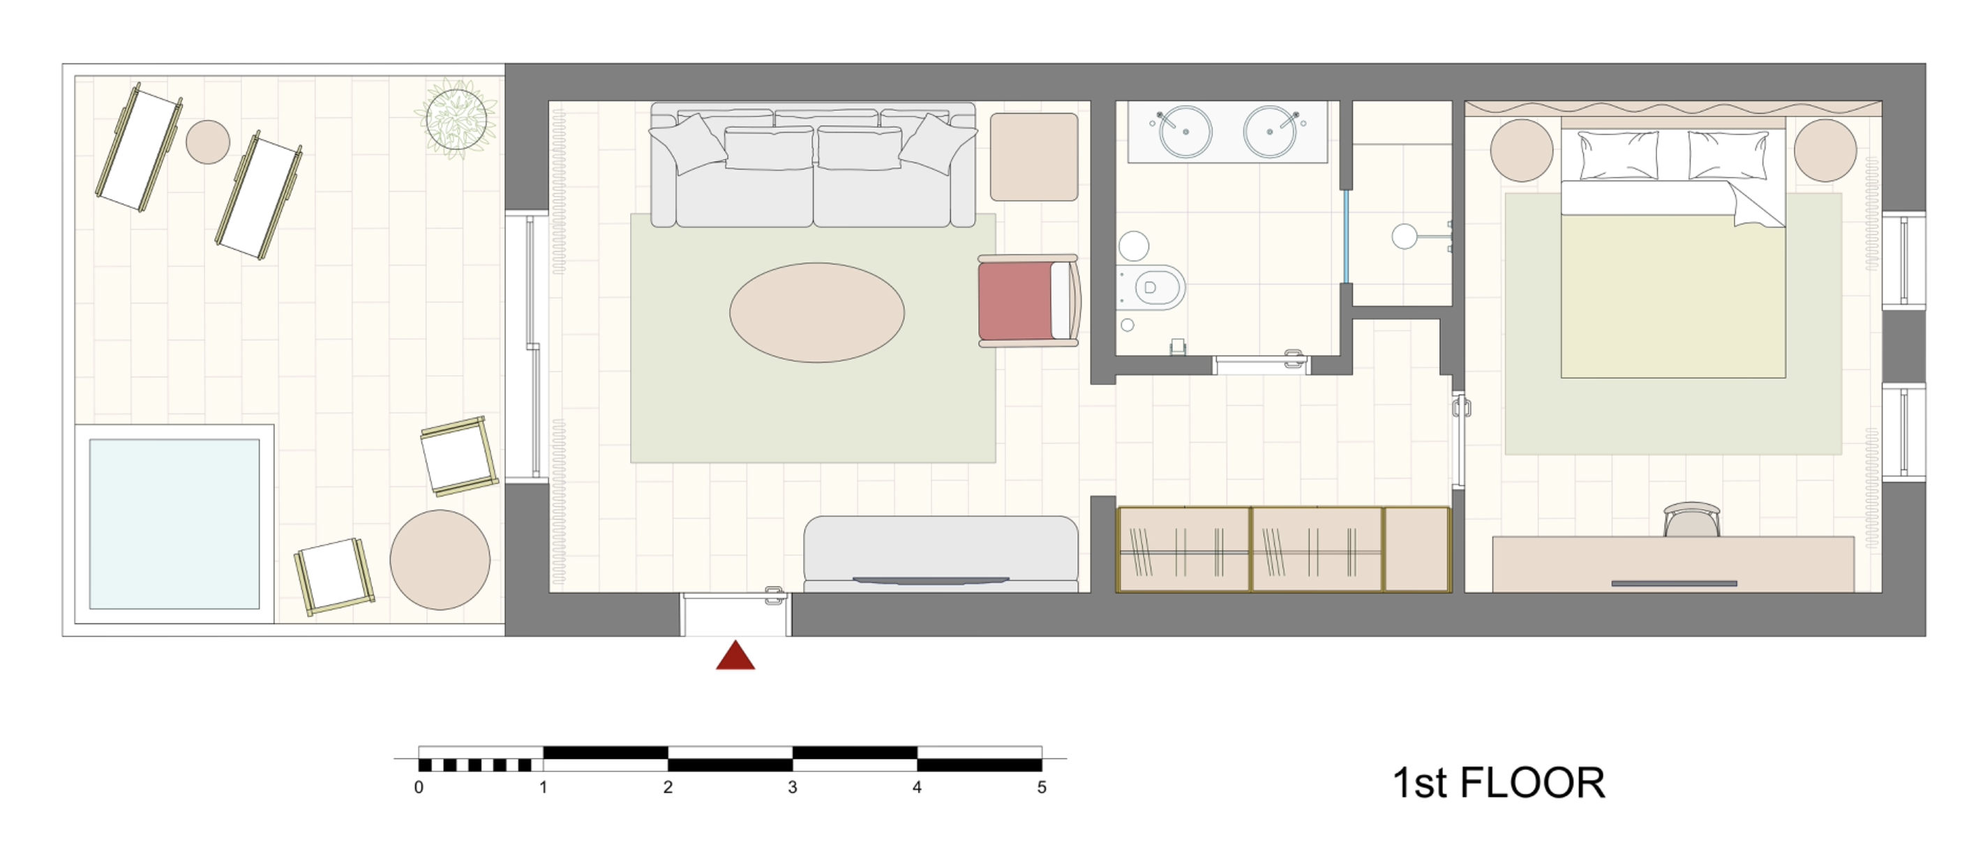

7. Beachfront Bliss Suite with Private Pool
Size | 50 sq m / 538 sq ft
Rooms available | 4 rooms
SLEEPING ARRANGEMENT | 1 bedroom space + living room with pull-out sofa
Layout / setup | Beachfront suite with private pool.
Nightly rate | Up to 4 persons: €900/night
Notes | The trip sheet identifies 4 rooms and a 4-person rate. Breakfast is included; rates are nightly and inclusive of taxes and fees.
Complete floorplan
https://www.pargabeachresort.gr/rooms/beachfront-bliss-suite-with-private-pool/https://www.pargabeachresort.gr/rooms/beachfront-bliss-suite-with-private-pool/
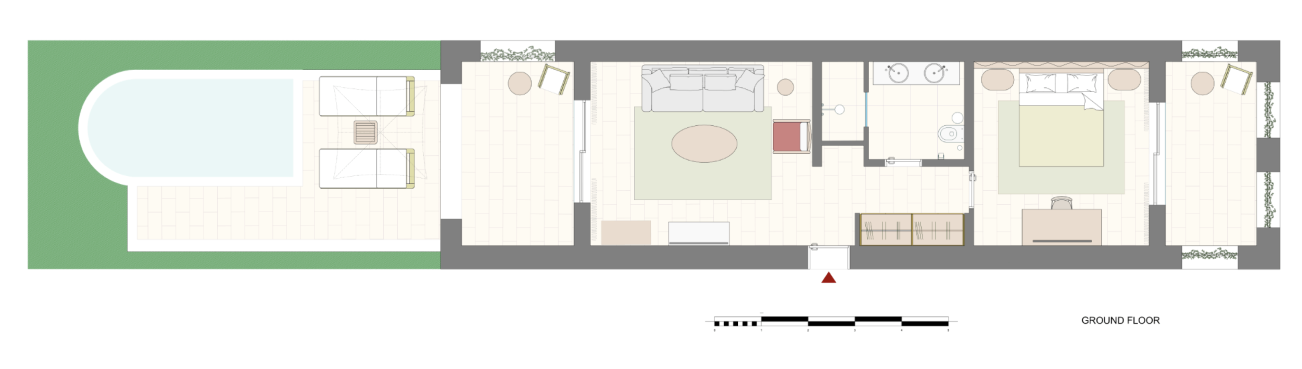

8. Beachfront Maison Suite with Private Pool
Size | 70 sq m / 753 sq ft
Rooms available | 4 rooms
SLEEPING ARRANGEMENT | 2 bedroom spaces + 2 baths + living room with pull-out sofa
Layout / setup | Two-level beachfront suite with private pool.
Nightly rate | Up to 4 persons: €1,250/night  Up to 5 persons: €1,300/night
Notes | The trip sheet notes 4–5 people, 2 bedroom spaces, 2 bathrooms, and a living room with pull-out sofa. Breakfast is included; rates are nightly and inclusive of taxes and fees.
Complete floorplan
https://www.pargabeachresort.gr/rooms/beachfront-maison-suite-with-private-pool/https://www.pargabeachresort.gr/rooms/beachfront-maison-suite-with-private-pool/
